Pinning Ceremony Student Information

Congratulations on reaching this point in your education and preparing for you Nursing Pinning Ceremony. This is an event in which you, your family, friends, School of Nursing faculty and other university members will share spiritual energy together while honoring your achievements here at the School of Nursing. The pinning ceremony is a proud nursing tradition which welcomes new nurses into the profession. Its roots go as far back as the time of the Crusades and continued in modern times through the accomplishments of Florence Nightingale. The first nursing pins were presented to nurses in America in the late 1800's. Nursing students receiving their nursing pin at this ceremony will join many California State University San Marcos students who have marked their transition from student to professional nursing practice with this event. Our nursing pin is unique with rich and meaningful symbolism that represents the special characteristics of our University and program.

The pinning ceremony is arranged in collaboration with members of the School of Nursing faculty, staff and cohort leaders. The following provides important information about how the pinning ceremony is managed.

Location, Date, Time & Catering
The location, date, time and catering is arranged by the SNA faculty advisors with the SNA president.

Location: University Student Union Ballroom

Catering: A menu of light refreshments is set with campus catering for this event.

Number of Attendees: The ballroom is arranged to accommodate 680 people. This includes graduates, faculty, and guests. 36 seats will be reserved for faculty.

Date & Time: The date of the ceremony is set far in advance of the event and determined by SoN faculty (SNA Advisors) and coordinated with campus event planners. It will occur on a day, close to the end of the last semester of nursing school for each cohort. If more than one cohort is graduating during the same semester, efforts will be made for both ceremonies to be on the same day, but held separately. As soon as the date is known, cohorts will be notified. Students do not arrange.

Dress Code:
- The cohort representative will lead the cohort to decide on overall attire theme. Most cohorts wear black.
- Men: a suit or slacks and a collared shirt, with or without a tie, and dress shoes are suggested.
- Women: a suit, slacks/skirt and blouse, or a dress, dress shoes, are suggested.
- In respect of the event, graduates are asked to not wear jeans, flip flops, tennis shoes, dresses or
blouse showing cleavage, backless/strapless apparel, tube tops, spaghetti strap tops, or sundresses. Very short skirts are discouraged.

Student Cohort Representatives:
It is up to the cohort to decide how many students are needed to coordinate the pinning ceremony. Two students as co-chairpersons is a consideration.

Pinning Ceremony Chairperson(s): Responsibilities:
- Communicate with the SNA Faculty Advisor for all ceremony details
- Determine by cohort ballot the following speakers
  - 2 Faculty members to announce graduates
  - 1 Student speaker to represent the cohort
- Lead cohort to arrange the following details of the ceremony (student expenses)
  - Photographer (optional)
  - Student attire for the ceremony including decision regarding stoles. The cohort may decide to wear all black with stoles or professional attire with lab coats. Sigma Theta Tau students should wear their cords.
  - Confirm attendees count 4 weeks prior to event and inform university event planner
- Use the template below to set the ceremony program. Forward to Faculty Advisor for approval. Arrange printing.
- Communicate to cohort regarding ordering pins when Faculty Advisor forwards ordering information. (Advisor is direct contact for Terry Berry, not students).
- Secure student assistants from other cohort to assists with event (2-4)
- Collaborate with Cohort Treasurer to finalize cost per student
- Use the template below for the faculty/staff invitation to the ceremony. 1 month prior to the event, email the invitation pdf to the SNA faculty advisors who will distribute to faculty and staff.
- 3X5 Cards: 1-2 weeks before the ceremony, arrange for students to write out an index card with their name (include phonetic spelling if needed), the name of the RN pinning them (phonetic spelling if needed), and the RN’s “relationship” to the student. Optionally include a brief message to friends, family, fellow classmates, faculty, etc. This card will be read as the student comes onstage to be pinned.
- Ensure your classmates get a quick run thru of the event details prior to the ceremony
- Option for pinning: pre-attach the pin to a 4 “blue ribbon and use large straight pins to pin to the student’s garment.
- Check to see if anyone that will be attending the ceremony has disabilities so you can arrange for proper stage entry and exit.

Pinning Ceremony Treasurer: Responsibilities:

The cost of the pinning ceremony will be shared by students. It is estimated to be $20-$30 per student. Actual costs will vary based on cohort selected items listed above. Venue and catering costs are set by the university based on # of attendees and may not be altered by students. Campus parking is available at standard parking rates. The top floor of the parking structure will be made available for parking at this event and included 114 parking spots. The cost of parking is split amongst Spring graduating cohorts and must be paid for entirely by Summer and Fall cohorts.

The following items are paid for by the cohort as a group on cost per student basis (total / # students cohort)
- Photographer (optional)
- Program printing
- Parking
- Decorations (optional) (can just be flowers on the stage however, none are needed)

Cohort SNA Representative:

- Serve to communicate pinning ceremony information to the cohort.
- Announce dates, times, location, parking, and other pertinent information to cohort.
- Alert cohort to Terry Berry ordering process and deadlines.
- Lead cohort to:
  - Assemble a pinning committee
  - Agree on attire theme
  - Hire a photographer, or opt not to
  - Select student speaker
  - Select faculty to read names (2 faculty)
  - Determine team to produce video

Cohort Treasurer Responsibilities:

- Collaborate with the cohort Pinning Ceremony Chairperson to determine cost per student
- Billing & payment for the venue and catering will be done through SNA, through Associated Students Inc directly.
- SNA will coordinate the process for payment of event and collection of fees from students.
  - Event will be paid for 2 weeks prior
  - SNA will collect money from individual cohort members via a “ticket,” which will be made available and announced by SNA prior to the event
    - Process for collecting money will be communicated by the current sitting board of SNA
- Individuals will be required to indicate whether or not they will be attending their pinning ceremony 1 month prior to the date of the event so that ticket process may be adjusted before collection.

Individual Student Expenses
Each student can expect the following pinning ceremony expenses.
- Share of group expenses as stated above
- Pin
- Stoles (cohort optional)

Pins
Each student purchases their own pin from Terry Berry, the company who manufactures the official CSUSM School of Nursing pin and tassel. A pin guard is also available. The tassel and pin guard are by individual student choice. There are options for metal and inset diamonds to choose from. The most basic pin is $44.00 (9/2019). The price of the pins varies depending on gold and silver markets and the metal chosen.
A website will become available specifically for each cohort for placing individual orders 2-3 months before the ceremony date. The Cohort Representative will make this order form available to students.

All cohort pins are sent in one package to the SoN to the attention of the SNA president. S/he will coordinate deliver to students. Pay close attention to the ordering deadline. Should a student miss that deadline, items may be ordered, but the student will pay individual shipping and handling and risk not having the pin in time for the ceremony.

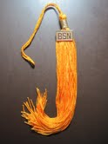
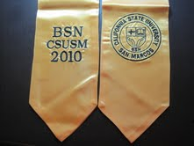
Stole are ordered from Terry Berry. The purchase of the stole is by cohort consensus

Program:
The program template is below. Students may prepare their own program, but must follow the template provided exactly.

Order of Ceremony
30 min. prior ceremony: Light refreshments offered to guests
Start of Ceremony Director, SoN or designee
5 minutes: Procession of Graduates
10 minutes: Opening remarks, Director, SoN or designee
10 minutes Student Address
40 minutes Presentation of the Graduates *(1 min/graduate)
10 minutes Presentation of Awards by Faculty
10 minutes Candle Ceremony, followed by International Pledge of Nursing: Director, SoN or designee
5 minutes Cohort Video
5 minutes Closing Remarks, Director, SoN or designee

Pinning Committee To Do Checklist
- Select faculty to assist in ceremony (announce names)
- Select student speaker
- Determine dress code for ceremony
- Communicate Terry Berry order information to cohort.
- Hire photographer
- Finalize number of attendees
- Arrange volunteers (2-4) from upcoming cohort to help with event (direct people)

Order of Ceremony  Welcome  Director, School of Nursing  Procession of Graduates  Director, School of Nursing  Opening Remarks  Director, School of Nursing]  Student Address  [Name of student]  Presentation of the Graduates  Faculty names & Credentials  Presentation of Faculty Awards  Director, School of Nursing  Candle Ceremony, International Pledge  Director, School of Nursing  Student Video  Closing Remarks  Director, School of Nursing |  |  | CSUMS School of Nursing  Accelerated Bachelor of Science in Nursing  Cohort 13  [name of students in 2 columns]  International Pledge for Nurses  In full knowledge of the obligation I am undertaking,  I promise to care for the sick with all the skills and understanding I possess without regard for race, creed, color, politics or social status sparing no effort to conserve life, to alleviate suffering and to promote health.  I will respect at all times the dignity and religious belief of the patients under my care, holding in confidence all personal information entrusted to me and refraining from any action, which might endanger life or health.  I will endeavor to keep my professional knowledge and skills at the highest level and to give loyal support and cooperation to all members of the health team.  I will do my utmost to honor the international code of ethics applied to nursing and to uphold the integrity of the registered professional nurse.
Acknowledgements  The class extends the following appreciations.  To the faculty and staff of the CSUSM School of Nursing for imparting us with your knowledge, wisdom, and leadership during our journey towards becoming excellent nurses of the future.  To the nursing and administrative staff of all clinical facilities for welcoming, engaging, and nurturing us throughout our growth into future nurses.  To families, friends, and loved ones for all their guidance, support, and endless patience.  Special Appreciations  [Optional if the cohort wishes to include any special acknowledgement] |  | California State University  San Marcos  School of Nursing  Pinning Ceremony  Bachelor of Science in Nursing  Cohort [#]  [date]

Directions to Pinning Ceremony

595 Campus View Drive
San Marcos, California 92078

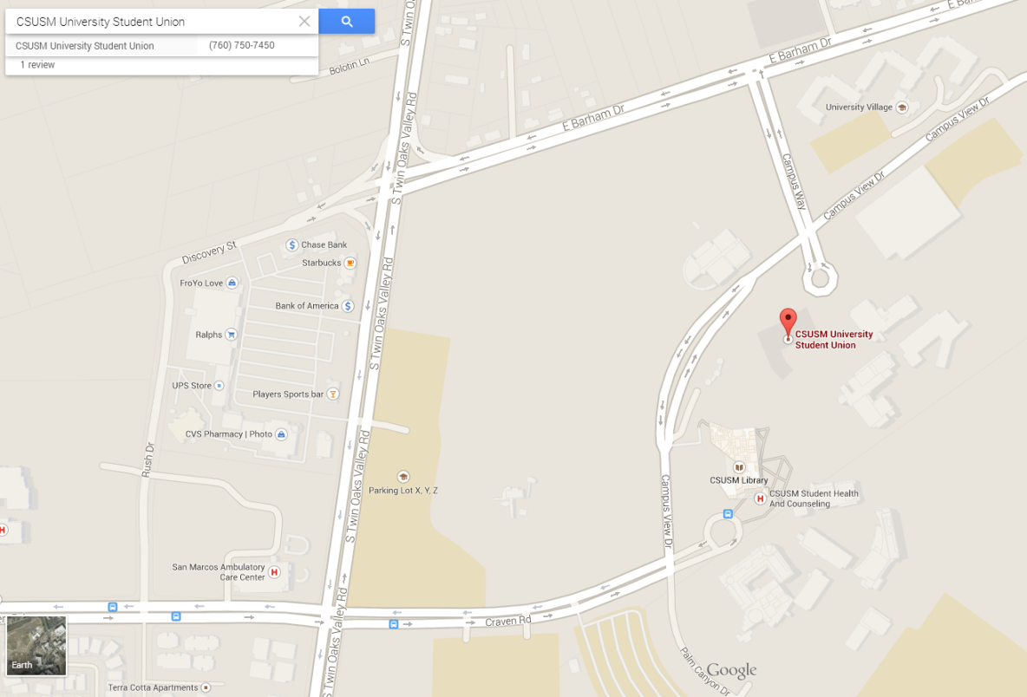
Parking Structure (Pay)

West Side Travelers (from I-5 head)
Head 78 East
Exit S. Twin Oaks Valley Rd. and Turn Right
Turn Left on E. Barham Dr.
Right on Campus Way
Left Campus View Dr.
Entrance to Parking Structure is on the Right

East Side Travelers (from I-15)
Head to 78 West
Exit S. Twin Oaks Valley Rd. and Turn Left
Turn Left on E. Barham Dr.
Right on Campus Way
Left on Campus View Dr.
Entrance to Parking Structure is on the Right

Parking is available on the 6th floor of Parking Structure 1. If parking runs out, you must pay for parking at an electronic parking kiosk (located on each floor of the structure)
Be sure to pay for the correct amount of time as parking is strictly enforced at all times
Once you have paid and found parking, find the South end Elevator (closest to the main part of school)
Cross Bridge
Make Right after bridge
University Student Union is the 2nd building on the right

